Revised: February 2023

BYLAWS OF

TUCKAHOE EQUESTRIAN CENTER FOUNDATION,

INC. ARTICLE I - NAME AND PURPOSE

- Name. Tuckahoe Equestrian Center Foundation, Inc. (The "Corporation") is a not-for­ profit, non-stock corporation organized under the Corporation and Association's Article of the Annotated Code of Maryland. Its offices and programs are located at Tuckahoe State Park, Ridgely, Maryland, 21660.

- Purposes. The purposes of the Corporation are:

  - Advance through the development and support of competitive programs and educational programs, amateur competition in national equestrian sports;

  - Assist the State of Maryland in developing the Tuckahoe Equestrian Center at Tuckahoe State Park as a venue for amateur equestrian competitions;

    - Provide educational programs for children and amateur sportsmen dealing with all facets of care, training, breeding, and competition of horses;

    - Raise funds for use in the above exempt activities and h,old/operate, acquire and maintain any and all properties, books, or records necessary to conduct the above activities;

    - Do all and any other actions permitted by corporate law of the State of Maryland.

ARTICLE II - MEMBERSHIP

- Classes of Membership. The membership of the Corporation shall be:
A. Directors. All Directors shall be members of the corporation by virtue of their

office.

- Officers. All officers of the Corporation shall be members of the Corporation by virtue of their office.

*C. Junior Members. All members under the .age of eighteen (18) years shall be junior members: Junior members shall be entitled to all benefits of membership except:

(1). They shall not be voting members of the corporation;

(2). They shall not serve as directors of the corporation;

(3). They shall not serve as officers of the corporation.

Nothing contained in these bylaws shall be construed to prohibit junior members from forming an educational club or youth group within the corporation and from serving as an officer of the said club or youth group.

- Other members. The Board of Directors may invite individuals and organizations who desire to become members of the Corporation and support the purposes for which Tuckahoe Equestrian Center Foundation, Inc. was organized to become members of the Corporation.

- Classes of membership and the benefits accruing to classes of membership and appropriate fee schedule may be designated by the Directors of the Corporation from time to time. Membership criteria will be without regard to race, sex, religion or political belief.

***F. Termination of Membership. Membership in Tuckahoe Equestrian Center Foundation, Inc. shall be terminated

(1 ). upon resignation by the member, or

    - upon non-payment of dues after a three (3) month grace period, or

    - by recommendation of the Board of Directors, provided the member has been notified in writing as to cause and permitted a full hearing before the Board of Directors. Such recommendation must be approved by two-thirds majority of all directors in person or by telephone vote.

- Annual Meeting. The annual meeting of the membership shall be held in the month of January at the offices of the Corporation or elsewhere as designated by the Board of Directors.

  - Notice of Meeting. Written of printed notice stating the place, date, day, and time and purposes of meeting, shall be mailed to all members not less than fifteen (15) days before the meeting.

ARTICLE Ill - BOARD OF DIRECTORS

- General Powers. The business and affairs of the Corporation shall be managed by the Board of Directors. The Board in all cases shall act as a unit, and individual members of the Board shall have no power to act independently of the Board. The Board shall have all the powers of the Corporation including, but not limited to, the power to make, amend, and abolish bylaws and other rules and regulations for the governance of the Corporation.

- Number, Tenure and Qualifications. The number of Directors of the Corporation shall number no less than three (3) and no more than fifteen (15) elected as provided below. The Directors shall be elected annually at the annual meeting from a slate prepared by the Nominating Committee. Nominees for a position on the Board of Directors must have attended a majority of the monthly meetings in the calendar year prior to January elections. The Board retains the right to make an exception to this attendance requirement on an individual basis, by majority vote.[*4] The Nominating Committee shall be appointed by the President at least sixty (60) days before the annual meeting. Each nominee to the Board of Directors must be present at the annual meeting at which his or her possible election to the Board will take place.

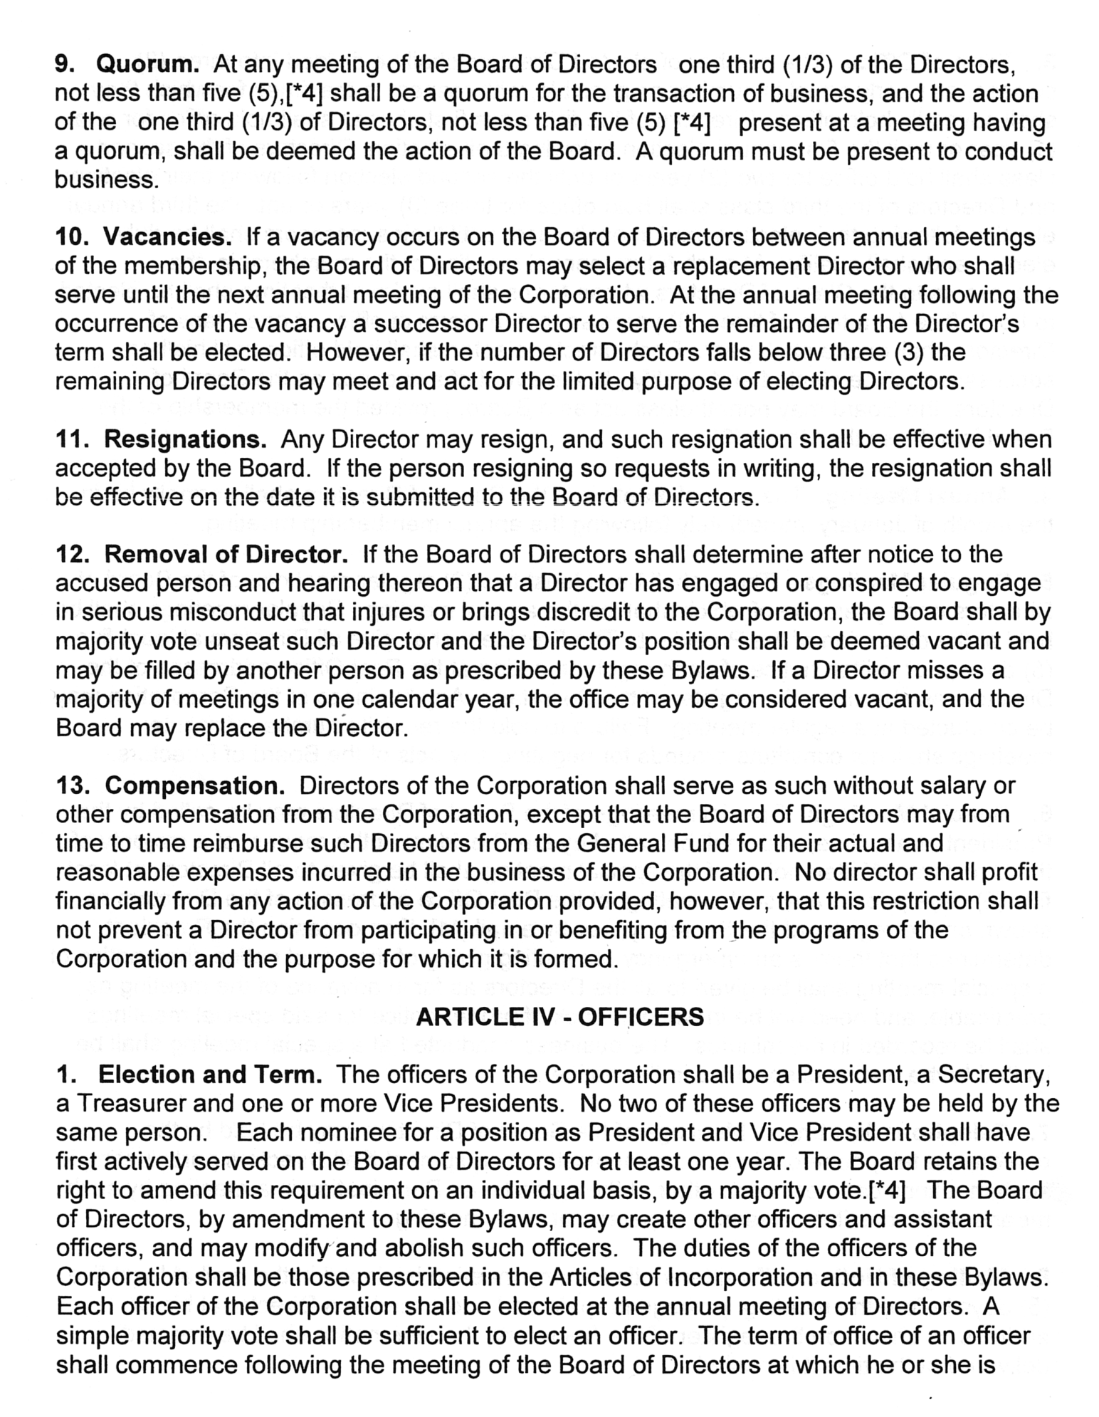

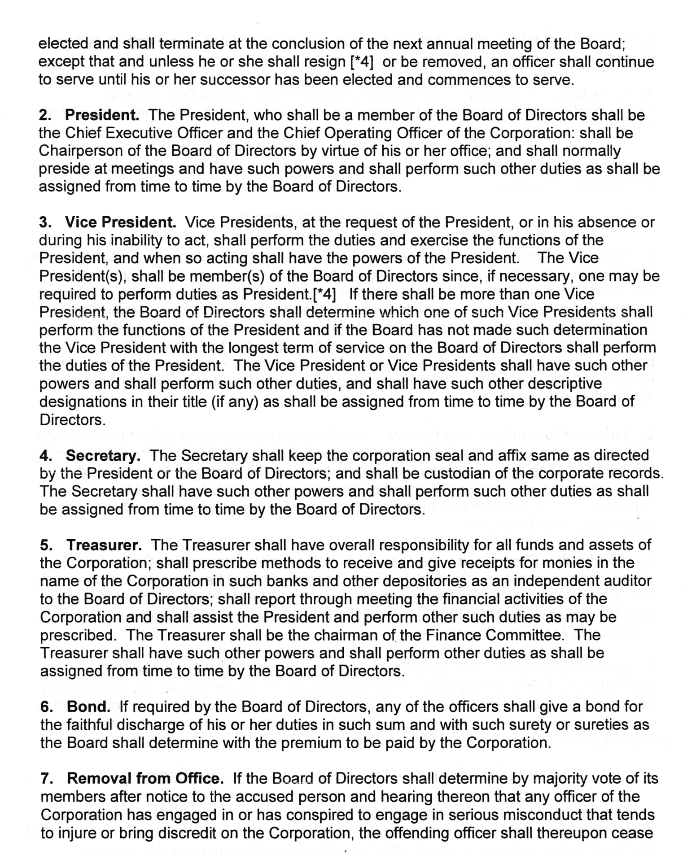

to be an officer and the office shall be deemed vacant, to be filled as prescribed by these Bylaws

- Vacancies. A vacancy in any office because of death, resignation, removal, disqualification or otherwise, may be filled by the Directors for the unexpired portion of the term.

- Conduct of Meeting. The Board of Directors shall follow Robert's Rules at its discrection for the conduct of meetings. [*5]

ARTICLE V - COMMITTEES

- Executive Committee. The President, Vice President, Secretary and Treasurer of the Corporation shall constitute the Executive Committee of the Corporation. They shall be empowered to make interim decisions between regular meetings of the Board of Directors which may be necessary from time to time to further the purposes of the Corporation. All such decisions shall be reported in writing to the Board at its next regular meeting. A simple quorum of the Executive Committee is required for the transaction of interim business which may necessitate a meeting of the Executive Committee. Meetings of the Executive Committee may be held telephonically under the same conditions as set out in Article 111, Section 7.

- Finance Committee. The Finance Committee shall prepare and submit to the Board of Directors a budget for the forthcoming fiscal year ninety (90) days prior to the beginning of such year. The Committee shall recommend investment strategies for funds of the Corporation and shall advise the Board on the general financial structure of the Corporation. The Finance Committee shall consist of at least three (3) members appointed by the President.

- Nominating Committee.The Board of Directors shall appoint a Nominating Committee consisting of at least two (2)members. The appointment shall be made not less than sixty (60) days prior to the annual meeting of the Directors. The Nominating Committee shall report in writing to the Board of Directors the names of the individuals nominated to serve as Directors for the forthcoming year. [*5]

  - Other Committees. The Board of Directors may by resolution designate other committees to further the purpose of the Corporation. Such committees should generally be chaired by a Director, but under special circumstances the Board may, at its discretion, appoint a chairman who is not a Director. Each committee shall serve at the pleasure of the President.

ARTICLE VI' - CONTRACTS, LOANS, CHECKS AND DEPOSITS

- Contracts. The Directors may authorize any officer or officers, agent or agents, to enter into any contract or execute and deliver any instrument in the name of or on behalf of the Corporation, and such authority may be ·broad or confined to a specific instance.

- Loans. No loans shall be contracted on behalf of the Corporation and no evidence of indebtedness shall be issued in its name unless authorized by a resolution of the Board of Directors. Such authority may be general or confined to specific instances.

- Checks, Drafts, Etc. All checks, drafts or other order for the payment of money, notes, or other evidence of indebtedness issued in the name of the Corporation shall be signed by such officer or officers, agent or agents of the Corporation and in such manner as shall from time to time be determined by resolutions of the Directors.

- Deposits. All funds of the Corporation not otherwise employed shall be deposited from time to time to the credit of the Corporation in such banks, trust companies or other depositories as the Directors may select.

ARTICLE VII - FISCAL YEAR

The fiscal year of the Corporation shall begin on the first day of January in each year.

ARTICLE VIII - REIMBURSEMENTS

Any payments made to an officer or other employee of the Corporation such as a commission, interest, or rent, or entertainment expenses incurred by him, which shall be disallowed in whole or in part as a deductible expense by the Internal Revenue Service, shall be reimbursed by such officer or other employee of the Corporation to the full extent of such disallowance. It shall be the duty of the Directors, as a Board, to enforce payment of each such amount disallowed. In lieu of such payment by the officer or other employee, subject to the determination of the Board of Directors, proportionate amounts may be withheld from his future reimbursement payments until the amount owed to the Corporation has been recovered.

ARTICLE IX - AMENDMENTS

These Bylaws may be amended, altered, or replaced by the vote of two-thirds (2/3) majority of the entire Board of Directors at any regular or special meeting provided the notices of meeting states that such action is proposed, and provided that a copy of each proposed amendment, alteration, or repeal is delivered to each of the Directors at least ten (10) days before the meeting at which matter is to be acted upon. If the material is placed in the mail to a Director at least fifteen (15) days before the meeting, postage prepaid and addressed to the Director at his or her address as shown on the register of the Secretary, then it shall be deemed delivered at the time it is mailed.

(11) Amended 12/05 by vote of the Board of Directors ** Amended 2/09 by vote of the Board of Directors

*** Amended by vote of Board of Directors and added to Bylaws November 2011 [*4] Article Ill #2, 6, 9; Art. IV: #1, 3 Amended by BOD; added to Bylaws Jan. 2018 [*5] Article V #3; Art. IV: 9 Amended by BOD; added to ByLaws February 2023

